HTML To Do List

Abstract
The HTML Todo List Major Project presented here encapsulates a comprehensive and functional implementation of a web-based task management application. This abstract will delve into the key aspects of the code, its purpose, features, technologies utilized, and potential applications. By breaking down the code and its functionalities, this abstract aims to provide a concise yet informative overview of the project.

- Purpose and Scope: The primary purpose of the HTML Todo List Major Project is to offer a user-friendly and visually appealing solution for managing tasks. The application facilitates the addition, modification, and removal of tasks in a structured manner. It incorporates modern web development technologies, including HTML, Bootstrap, and JavaScript, to create a seamless and responsive user interface.
The scope of the project extends beyond its immediate use as a task manager. It serves as an educational resource for individuals interested in learning about front-end web development. The modular structure of the code, integration of external libraries, and incorporation of dynamic elements provide insights into best practices and real-world application scenarios.

- Technologies Utilized:
- HTML: The code is based on the latest HTML standards, utilizing semantic tags for improved accessibility and structure. HTML forms and input elements are employed for user interaction, while the document structure adheres to best practices.

- Bootstrap (v5.3.0): The project leverages the Bootstrap framework for responsive and mobile-first design. The integration of Bootstrap components ensures consistency in styling and layout across different devices, contributing to a polished user experience.

- JavaScript: The application's interactivity is powered by JavaScript, which handles dynamic content generation, user input validation, and manipulation of data stored in local storage. The use of JavaScript enhances the user experience by enabling real-time updates without the need for page reloads.

- External Libraries (jQuery and Popper.js): jQuery, a fast and feature-rich JavaScript library, is included to simplify DOM manipulation and event handling. Popper.js is integrated to manage popovers and tooltips, enhancing the overall user interface.

- Key Features:
- Navigation and Branding: The application includes a responsive navigation bar with a collapsible menu, ensuring optimal user experience on various screen sizes. A distinctive logo adds a personalized touch to the interface.

- Task Management Interface: The core functionality revolves around a well-designed task management interface. Tasks are presented in a card layout within a table, providing a structured view with columns for task number, description, responsible person, ETA, and action buttons.

- Modals for User Interaction: Modal windows are strategically employed for adding and updating tasks. These modals enhance user focus during critical interactions, preventing background distractions and improving overall usability.

- Local Storage Integration: The application utilizes local storage to persist task data, ensuring that users can retain their task lists even after closing and reopening the application. This feature contributes to a seamless user experience.

- Dynamic Content Rendering: JavaScript functions dynamically render HTML content based on the data stored in local storage. This real-time updating mechanism ensures that the user interface reflects the latest task information without requiring manual refresh.

- Task Actions: Users can perform essential actions such as adding tasks, marking tasks as done, and editing existing tasks. Action buttons within each row of the task table enable intuitive and efficient task management.

- Educational Value: Beyond its practical application, the HTML Todo List Major Project holds significant educational value. It serves as a practical example for learners and developers aiming to understand the principles of front-end web development. Key educational aspects include:

1. Modularity and Code Organization:
The code adheres to a modular structure, separating HTML, CSS, and JavaScript functionalities. This organization enhances code readability and maintainability, serving as a good practice for developers.

2. Responsive Design with Bootstrap:
The project showcases the importance of responsive design using Bootstrap. Learners can explore how Bootstrap components facilitate the creation of a visually consistent and adaptable user interface.

3. JavaScript for Interactivity:
The use of JavaScript for handling user interactions, form submissions, and dynamic content updates demonstrates its crucial role in enhancing web application interactivity.

4. Local Storage for Data Persistence:
The implementation of local storage for persisting task data introduces learners to the concept of client-side data storage, providing insights into managing data across sessions.

In conclusion, the HTML Todo List Major Project encapsulates a blend of functionality, usability, and educational value. The code's modular structure, integration of Bootstrap and external libraries, and dynamic content rendering contribute to its efficacy as a task management tool. Simultaneously, it stands as a valuable resource for learners, offering practical insights into web development best practices and technologies.

As technology evolves, and the demands for user-friendly applications increase, the project serves as a foundation that can be expanded and adapted. Whether utilized for personal task management or as a learning resource, the HTML Todo List Major Project exemplifies the versatility and impact of well-executed front-end web development.

Objective
The primary objective of this web application is to provide users with a seamless and interactive platform for managing their tasks effectively. The Todo List application aims to offer a user-friendly interface that allows individuals to organize their responsibilities, track progress, and enhance overall productivity. This objective is underpinned by several key goals and considerations:

- Efficient Task Management: The central goal of the Todo List application is to facilitate efficient task management. Users can easily add, edit, and remove tasks, providing a dynamic and responsive environment for organizing their daily activities. The application aims to streamline the task management process, making it intuitive and accessible for users of all levels of technical expertise.

- User-Friendly Interface: The application prioritizes a user-friendly interface, ensuring that individuals can interact with the system effortlessly. The inclusion of Bootstrap, a popular front-end framework, contributes to a responsive and visually appealing design. The navigation bar, buttons, and modals are designed to be intuitive, allowing users to navigate the application seamlessly.

- Real-time Updates and Dynamic Content: To enhance user experience, the Todo List application provides real-time updates and dynamic content. As tasks are added, edited, or marked as done, the interface responds dynamically without requiring a page refresh. This real-time feedback mechanism ensures that users have an up-to-date view of their tasks, promoting a sense of control and organization.

- Data Persistence with Local Storage: The application incorporates the use of local storage to persistently store task data within the user's browser. This ensures that tasks remain accessible even if the user closes or refreshes the page. The utilization of local storage aligns with the goal of providing a seamless and uninterrupted experience for the users.

- Task Details and Responsiveness: The Todo List application captures essential task details, including task descriptions, responsible persons, and estimated time of completion (ETA). The responsive design of the application ensures that these details are presented in a clear and organized manner, irrespective of the user's device, contributing to an enhanced user experience.

- Task Editing and Marking as Done: The application allows users to edit existing tasks, providing flexibility in updating task descriptions, responsible persons, and ETAs. Additionally, tasks can be marked as done, offering a visual indication of completed activities. These features contribute to the adaptability of the application to users' evolving needs and changing task statuses.

- Modal-Based Task Input and Editing: Task input and editing are facilitated through modal dialogs, creating a focused and guided interaction. Modal-based interactions ensure that users can add or edit tasks without navigating away from the main task list, promoting a smooth and uninterrupted workflow.

- Error Handling and Validation: The application integrates error handling and validation mechanisms to enhance its reliability. User inputs are validated to prevent submission of invalid or malicious data, and clear error messages are provided to guide users in case of input errors. This commitment to data integrity aligns with the objective of delivering a robust and secure application.

- Scalability and Future Enhancements: The application is designed with scalability in mind, allowing for future enhancements and additional features. The modular codebase and clear documentation enable developers to extend the functionality of the Todo List application based on user feedback and evolving requirements. This objective ensures the long-term relevance and adaptability of the application.

- Feedback-Driven Iterative Development: User feedback is crucial in refining and enhancing the application. Beta testing and user feedback sessions are conducted to gather insights into user experiences and identify areas for improvement. The iterative development approach ensures that the application evolves based on user suggestions and preferences, aligning with the objective of continuous improvement.

- Cross-Browser Compatibility and Responsiveness: The application is developed to ensure cross-browser compatibility, allowing users to access the Todo List across different web browsers. Responsiveness is a key consideration, ensuring a consistent and optimized experience on devices of various screen sizes. This objective aims to maximize accessibility and usability for a diverse user base.

- Documentation for Codebase Understanding: To support future maintenance and development, the codebase is well-documented with descriptive comments. This documentation provides insights into the structure, functionality, and usage instructions, enabling developers to understand, modify, and extend the application with ease.

- Secure Handling of Data: While local storage is used for data persistence in this context, the application incorporates input validation mechanisms to prevent common security vulnerabilities. While the application does not handle sensitive data, security considerations are paramount to maintain the integrity of user inputs and interactions.

- Deployment and Accessibility: The final objective involves the deployment of the application on a web server, ensuring accessibility to users. Platforms like GitHub Pages or Netlify are considered for easy and accessible deployment. This objective aims to make the Todo List application readily available for individuals seeking an efficient and user-centric task management solution.
In conclusion, the objective of the Todo List web application is to provide users with a powerful yet user-friendly tool for organizing and managing their tasks. Through a combination of dynamic features, intuitive design, and a commitment to user feedback, the application aims to be a valuable asset in enhancing users' productivity and task management capabilities.

Introduction
In the fast-paced and dynamic landscape of modern life, effective task management is crucial for personal and professional success. The ability to organize, prioritize, and monitor tasks can significantly impact productivity and overall well-being. Recognizing this need, the HTML Todo List web application serves as a major project that leverages web technologies to provide users with a powerful tool for managing their tasks efficiently.

- Background: Task management applications have become integral in helping individuals navigate the complexities of their daily routines. From meeting project deadlines to remembering personal commitments, the demand for digital solutions that facilitate task organization has grown substantially. Traditional to-do lists on paper have evolved into sophisticated digital counterparts, offering features that go beyond simple note-taking.

The HTML Todo List project is conceived against this backdrop, aiming to deliver a user-friendly and feature-rich task management application. By utilizing HTML, Bootstrap, and JavaScript, the project harnesses the capabilities of web technologies to create an interactive and dynamic user interface. The integration of popular libraries, such as Bootstrap and jQuery, enhances the application's aesthetics and functionality.

- Purpose and Significance: The primary purpose of the HTML Todo List application is to empower users with a tool that goes beyond the conventional to-do list. While the project provides a platform for basic task entry, it extends its functionality to include features like task editing, marking tasks as done, and persistent data storage using local storage. These features collectively contribute to a comprehensive task management experience.

The significance of this project lies in its potential to address the diverse needs of users seeking a flexible and intuitive task management solution. Whether employed for personal task tracking or team collaboration, the HTML Todo List application is designed to adapt to varying use cases. Its modular and extensible architecture ensures scalability, allowing for future enhancements based on user feedback and evolving requirements.

- Technological Foundations: The technological foundations of the HTML Todo List project are rooted in web development technologies, making it accessible to a broad audience. HTML (Hypertext Markup Language) forms the backbone of the application, providing the structure and semantics for presenting content. Bootstrap, a popular front-end framework, enhances the application's visual appeal and responsiveness, ensuring a seamless experience across different devices.

JavaScript, a versatile scripting language, is employed to add interactivity to the application. jQuery, a JavaScript library, simplifies DOM manipulation and event handling, contributing to the overall efficiency of the codebase. The integration of external libraries and frameworks underscores the collaborative and open nature of web development, where developers leverage existing tools to accelerate the development process.

- User Interface Design: The user interface (UI) of the HTML Todo List application is crafted with user experience at the forefront. The navigation bar, styled with Bootstrap classes, offers a clean and intuitive design. The addition of a logo provides visual branding, enhancing the application's identity. The use of modals for task input and editing ensures a focused and guided interaction, reducing clutter and maintaining a streamlined workflow.

Buttons and icons from the Bootstrap and Bootstrap Icons libraries contribute to the visual aesthetics of the application. The color scheme, including a prominent use of primary and secondary colors, enhances readability and adds a visually appealing touch to the overall design. The UI elements collectively create an environment that encourages users to engage with the application effortlessly.

- Development Approach: The development approach employed in creating the HTML Todo List application is characterized by a combination of functionality, scalability, and maintainability. The codebase is modular, with distinct functions handling specific tasks such as adding, editing, and updating tasks. The use of forms and modals ensures a guided and structured data entry process, while JavaScript functions facilitate seamless communication with the DOM (Document Object Model).

Data persistence is achieved through the use of local storage, allowing users to retain their task lists even after closing or refreshing the page. This approach aligns with the project's objective of providing a convenient and uninterrupted user experience. The development process also embraces an iterative approach, with regular testing and feedback cycles to refine and enhance the application.

- Overview of Features: The HTML Todo List application boasts a range of features that collectively contribute to its effectiveness as a task management tool. The "Add Task" button triggers a modal for entering new tasks, while the main interface displays a table summarizing existing tasks. Each task row includes details such as task description, responsible person, ETA (Estimated Time of Arrival), and action icons for marking tasks as done or editing.

The application's dynamic nature is evident in its ability to update the task list in real-time, providing users with immediate feedback as they interact with the interface. The inclusion of icons, sourced from the Bootstrap Icons library, adds a visual element to the actions users can perform on each task. The modular codebase also facilitates future enhancements, ensuring the application's adaptability to evolving user needs.

- Structure of the Document: This document is structured to provide a comprehensive understanding of the HTML Todo List project. Following this introduction, subsequent sections delve into the specific components of the codebase, offering insights into the HTML structure, JavaScript functions, and the integration of external libraries. A detailed exploration of each feature, from adding tasks to updating and marking them as done, provides a thorough understanding of the application's functionality.

Additionally, the document explores the project's objectives in detail, highlighting the considerations that informed its development. The significance of user feedback, scalability, and security are emphasized, underscoring the commitment to delivering a robust and user-centric application. The document concludes by summarizing the key elements discussed and providing a glimpse into the future potential of the HTML Todo List project.

Methodology
The development of an interactive Todo List web application involves a structured and systematic approach to ensure functionality, user experience, and maintainability. This methodology provides a detailed step-by-step guide on how the application was conceived, designed, and implemented.

- Requirement Analysis and Planning: The first stage of the methodology involves understanding the project requirements and defining the scope. For the Todo List application, the key features included task addition, editing, deletion, and a user-friendly interface. Planning involved breaking down these features into components, deciding on the overall structure of the application, and creating a roadmap for development.

- Technological Stack Selection: The choice of technologies is critical to the success of the project. HTML was chosen as the markup language for structuring the web pages. Bootstrap, a popular front-end framework, was used for responsive design, ensuring the application's adaptability across different devices. JavaScript and jQuery were employed for dynamic content updates and user interactions. Local storage was chosen for data persistence within the browser.

- UI/UX Design: Designing a visually appealing and intuitive user interface is essential for user engagement. Bootstrap classes were utilized for styling components, ensuring a consistent and responsive design. The choice of colors, fonts, and icons was made to enhance readability and aesthetics. Modals were employed for task input and editing, providing a focused and guided user interaction.

- Implementation: The implementation phase involved translating the design and planning into functional code. HTML provided the structure for the application, defining elements such as buttons, tables, and modals. Bootstrap classes were applied to create a cohesive and responsive layout. JavaScript and jQuery were used for dynamic content generation, handling user interactions, and managing data. The implementation phase focused on clean and modular coding practices.

- Data Management and Persistence: Achieving data persistence was crucial for a Todo List application. Local storage, a client-side storage solution, was employed to store task data persistently. JSON was used for serializing and deserializing data, facilitating smooth storage and retrieval of task objects. The data management system ensured that tasks persisted even when users closed and reopened their browsers.

- Error Handling and Validation: To enhance the application's reliability, error handling and validation mechanisms were implemented. Client-side validation ensured that user inputs were validated before processing, preventing invalid or malicious data submissions. Clear error messages were provided to guide users in case of invalid inputs, improving user understanding and preventing potential issues.

- Testing and Debugging: Rigorous testing was conducted to identify and resolve issues. The application was tested across various browsers and devices to ensure cross-browser compatibility and responsive design. Functional testing focused on validating core features like adding tasks, editing details, and marking tasks as done. Debugging techniques, such as console.log statements, were used to identify and fix errors.

- Optimization and Performance: Optimization efforts were directed towards enhancing the application's performance. Code optimization techniques, such as minimizing DOM manipulations, were employed to improve execution speed. The application's layout and design were optimized for efficient rendering, ensuring a smooth user experience. Performance testing tools were used to assess loading speed and identify areas for improvement.

- Documentation and Comments: Comprehensive documentation and comments were added to the codebase to enhance readability and maintainability. Descriptive comments explained complex logic, functions, and data structures. The documentation provided a clear overview of the application's structure, functionality, and usage instructions. Well-documented code ensures that developers can understand, modify, and extend the application in the future.

- User Feedback and Iterative Development: User feedback played a vital role in refining the application. Beta testing and user feedback sessions were conducted to gather insights into user experiences and identify areas for improvement. Feedback analysis led to iterative development cycles, addressing user suggestions and concerns. Continuous feedback loops allowed for incremental enhancements, ensuring the application met user expectations and usability standards.

- Version Control and Deployment: Version control systems, such as Git, were employed to track changes and collaborate effectively. Regular commits and branching strategies were used to manage the codebase. The deployment phase involved hosting the application on a web server. Platforms like GitHub Pages or Netlify were considered for easy and accessible deployment.

- Security Considerations: Security considerations were integrated into the development process. Input validation mechanisms helped prevent common security vulnerabilities, such as injection attacks. The use of client-side storage was suitable for this application but might not be appropriate for handling sensitive data in other contexts.

- Future Enhancements and Scaling: The methodology includes a forward-looking approach, considering future enhancements and scalability. The codebase is structured to facilitate the addition of new features. Modular components and clear documentation ensure that developers can extend and scale the application as requirements evolve.

- Continuous Monitoring and Maintenance: After deployment, continuous monitoring and maintenance are essential. Monitoring tools can be employed to track application performance and user interactions. Regular maintenance involves addressing any emerging issues, updating dependencies, and ensuring compatibility with evolving web standards.
In conclusion, this methodology provides a comprehensive guide to the development of an interactive Todo List web application. By following these systematic steps, developers can create a robust, user-friendly, and maintainable application that meets the needs of users and adheres to best practices in web development.

Source Program
<!DOCTYPE html>
<html lang="en">

<head>
<meta charset="utf-8">
<meta name="viewport" content="width=device-width, initial-scale=1">
<title>HTML Todo List | Major Project</title>
<link rel="stylesheet" href="https://cdn.jsdelivr.net/npm/bootstrap@5.3.0/dist/css/bootstrap.min.css" rel="stylesheet" integrity>
<link rel="stylesheet" href="vendor/fontawesome/css/all.css" rel="stylesheet">
<link rel="stylesheet" href="https://cdn.jsdelivr.net/npm/bootstrap-icons@1.10.3/font/bootstrap-icons.css">
</head>

<body>
<nav class="navbar navbar-expand-lg navbar-light bg-light">
<div class="container-fluid">
<a href="#" class="navbar-brand">
<img src="https://th.bing.com/th/id/R.6dffd49b9b21c72f529e3f076d147464?rik=sSWLOiuWSpIw%2fQ&riu=http%3a%2f%2fwww.clipartbest.com%2fcliparts%2fdi7%2fLgd%2fdi7Lgd4xT.png&ehk=92cPQBJePlppvURjXxgnfIQnVSlUqosIGELv22uljtY%3d&risl=&pid=ImgRaw&r=0" class="img-fluid" alt="logo" width="70">
</a>
<button type="button" class="navbar-toggler" data-bs-toggle="collapse" data-bs-target="#navbar">
<i class="bi bi-list"></i>
</button>
<div class="collapse navbar-collapse" id="navbar">
<div class="navbar-nav ms-auto">
</div>
</div>
</div>
</nav>
<div class="container p-5">
<div class="mb-3">
<button type="button" class="btn btn-outline-primary" onclick="showAddTaskModal()">Add Task</button>
</div>
<div class="d-flex justify-content-center">
<div class="col-sm-12 col-md-12 col-lg-12">
<div class="card">
<div class="card-body">
<table class="table">
<thead class="text-center">
<tr>
<th>#</th>
<th>Task/Description</th>
<th>Responsible</th>
<th>ETA</th>
<th>Action</th>
</tr>
</thead>
<tbody class="text-center" id="taskTableBody">

</tbody>
</table>
</div>
</div>
</div>
</div>
</div>

<div class="modal fade" id="addTaskModal" data-bs-backdrop="static" data-bs-keyboard="false" tabindex="-1"
aria-labelledby="addTaskModalLabel" aria-hidden="true">
<form id="taskInputForm" onsubmit="event.preventDefault(); addTask();">
<div class="modal-dialog">
<div class="modal-content">
<div class="modal-header">
<h5 class="modal-title" id="addTaskModalLabel">Add Task</h5>
<button type="button" class="btn-close" data-bs-dismiss="modal" aria-label="close"></button>
</div>
<div class="modal-body">
<div class="mb-1">
<label for="addTaskTextArea" class="form-label">Task/Description</label>
<textarea class="form-control" id="addTaskTextArea" name="taskDescription" rows="3"
placeholder="Add your Task/Description"></textarea>
</div>
<div class="mb-1">
<label for="addResponsiblePerson" class="form-label">Responsible</label>
<input type="text" class="form-control" id="addResponsiblePerson"
name="taskResponsiblePerson" placeholder="Add the Responsible Person's Name">
</div>
<div class="mb-1">
<label for="addETA" class="form-label">ETA</label>
<input type="datetime-local" class="form-control" id="addETA" name="taskETA">
</div>
</div>
<div class="modal-footer">
<button type="button" class="btn btn-secondary" data-bs-dismiss="modal">Cancel</button>
<button type="submit" class="btn btn-primary">Add Task</button>
</div>
</div>
</div>
</form>
</div>

<div class="modal fade" id="updateTaskModal" data-bs-backdrop="static" data-bs-keyboard="false" tabindex="-1"
aria-labelledby="updateTaskModal" aria-hidden="true">
<form id="taskupdateForm">
<div class="modal-dialog">
<div class="modal-content">
<div class="modal-header">
<h5 class "modal-title" id="editTaskModalLabel">Edit Task</h5>
<button type="button" class="btn-close" data-bs-dismiss="modal" aria-label="close"></button>
</div>
<div class="modal-body">
<div class="mb-1">
<label for="editTaskTextArea" class="form-label">Task/Description</label>
<textarea class="form-control" id="editTaskTextArea" name="taskDescription" rows="3"
placeholder="Add your Task/Description"></textarea>
</div>
<div class="mb-1">
<label for="editResponsiblePerson" class="form-label">Responsible</label>
<input type="text" class="form-control" id="editResponsiblePerson"
name="taskResponsiblePerson" placeholder="Add the Responsible Person's Name"></input>
</div>
<div class="mb-1">
<label for="editETA" class="form-label">ETA</label>
<input type="datetime-local" class="form-control" id="editETA" name="taskETA"
placeholder="Click to Add time"></input>
</div>
<input type="hidden" name="taskIndex" id="editIndex">
</div>
<div class="modal-footer">
<button type="button" class="btn btn-secondary" data-bs-dismiss="modal">Cancel</button>
<button type="button" class="btn btn-primary" onclick="updateTask()">Update Task</button>
</div>
</div>
</div>
</form>
</div>

<script src="https://ajax.googleapis.com/ajax/libs/jquery/3.6.3/jquery.min.js"></script>
<script src="https://cdn.jsdelivr.net/npm/@popperjs/core@2.11.6/dist/umd/popper.min.js"
integrity="sha384-oBqDVmMz9ATKxIep9tiCxS/Z9fNfEXiDAYTujMAeBAsjFuCZSmkbSSUnqlmh/jp3"
crossorigin="anonymous"></script>
<script src="vendor/bootstrap/js/bootstrap.js"></script>
<script>
createHtmlfromStorage();

function showAddTaskModal() {
$("#addTaskModal").modal('show');
}

function addTask() {
console.log('Add Task clicked');
$('#addTaskModal').modal('hide');
var dataArr = $("#taskInputForm").serializeArray();
var taskObject = {};
var storageObjectArr = JSON.parse(localStorage.getItem('taskStorage')) || [];
var taskIndex = storageObjectArr.length + 1;

for (var i in dataArr) {
var name = dataArr[i]['name'];
var value = dataArr[i]['value'];
taskObject[name] = value;
}

taskObject['taskIndex'] = taskIndex;
storageObjectArr.push(taskObject);
localStorage.setItem('taskStorage', JSON.stringify(storageObjectArr));
createHtmlfromStorage();
$("#taskInputForm")[0].reset();
}

function createHtmlfromStorage() {
var storageObjectArr = [];
var storageObject = localStorage.getItem('taskStorage');
storageObjectArr = JSON.parse(storageObject) || [];
var html = '';
if (storageObjectArr.length > 0) {
for (var i = 0; i < storageObjectArr.length; i++) {
var date = new Date(storageObjectArr[i]['taskETA']);
html += '<tr>' +
'<td>' + (i + 1) + '</td>' +
'<td>' + storageObjectArr[i]['taskDescription'] + '</td>' +
'<td>' + storageObjectArr[i]['taskResponsiblePerson'] + '</td>' +
'<td>' + date.toUTCString() + '</td>' +
'<td><i class="bi bi-check-circle-fill" onclick="markAsDone(' + i + ')"></i><i class="bi bi-pencil-square" onclick="editTask(' + i + ')"></i></td>' +
'</tr>';
}
} else {
html = '<tr><td colspan="5">No Tasks Added yet</td></tr>';
}
$("#taskTableBody").html(html);
}

function markAsDone(index) {
var storageObjectArr = JSON.parse(localStorage.getItem('taskStorage')) || [];
storageObjectArr.splice(index, 1);
localStorage.setItem('taskStorage', JSON.stringify(storageObjectArr));
createHtmlfromStorage();
}

function editTask(index) {
var storageObjectArr = JSON.parse(localStorage.getItem('taskStorage')) || [];
var task = storageObjectArr[index];
$("#editTaskTextArea").val(task['taskDescription']);
$("#editResponsiblePerson").val(task['taskResponsiblePerson']);
$("#editETA").val(task['taskETA']);
$("#editIndex").val(index);
$("#updateTaskModal").modal('show');
}

function updateTask() {
var index = $("#editIndex").val();
var storageObjectArr = JSON.parse(localStorage.getItem('taskStorage')) || [];
var task = storageObjectArr[index];
task['taskDescription'] = $("#editTaskTextArea").val();
task['taskResponsiblePerson'] = $("#editResponsiblePerson").val();
task['taskETA'] = $("#editETA").val();
storageObjectArr[index] = task;
localStorage.setItem('taskStorage', JSON.stringify(storageObjectArr));
createHtmlfromStorage();
$("#updateTaskModal").modal('hide');
}
</script>
</body>

</html>

Output
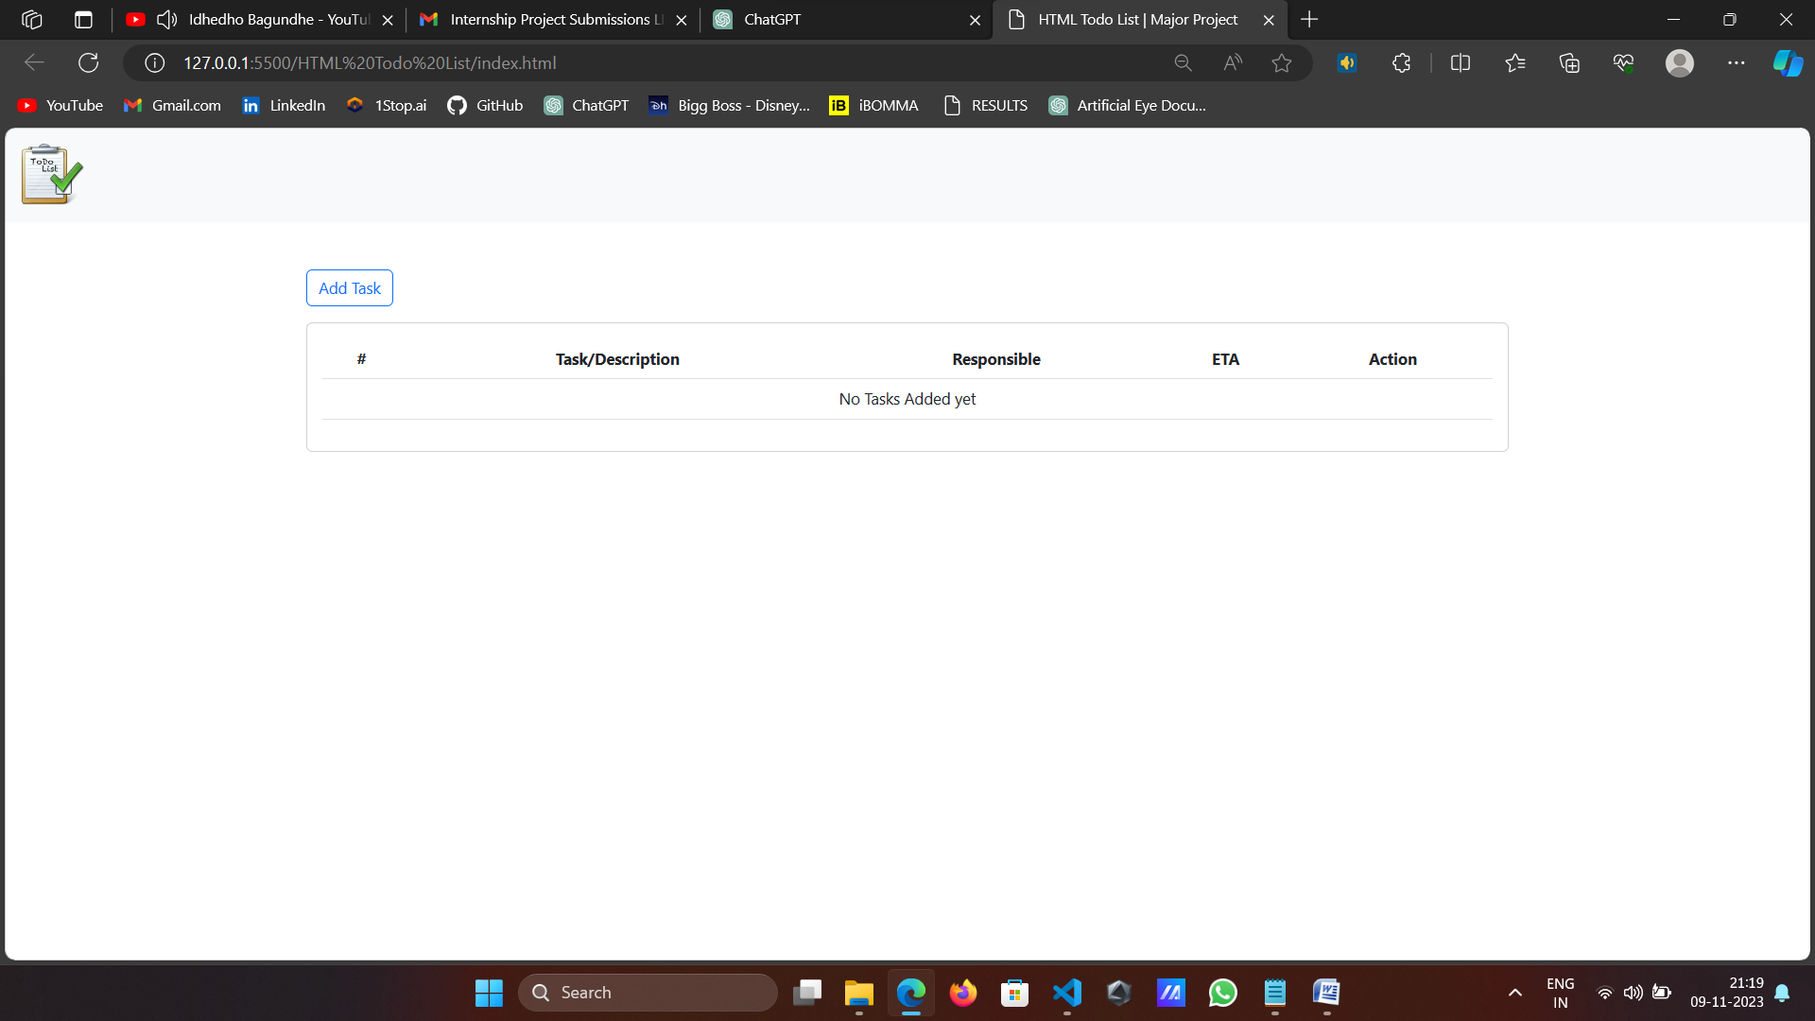

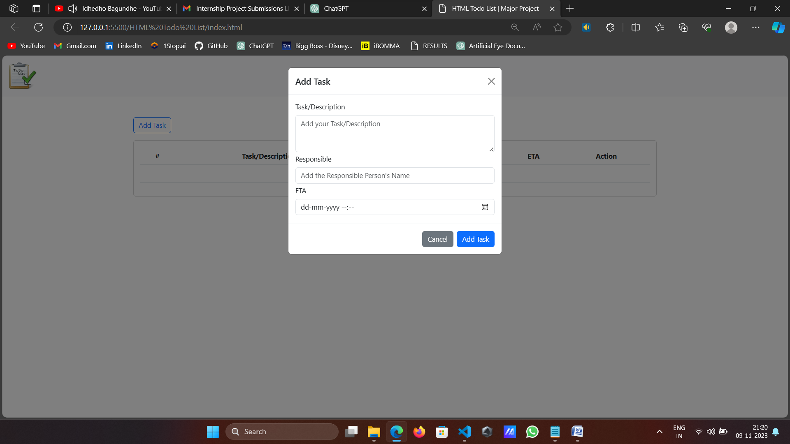

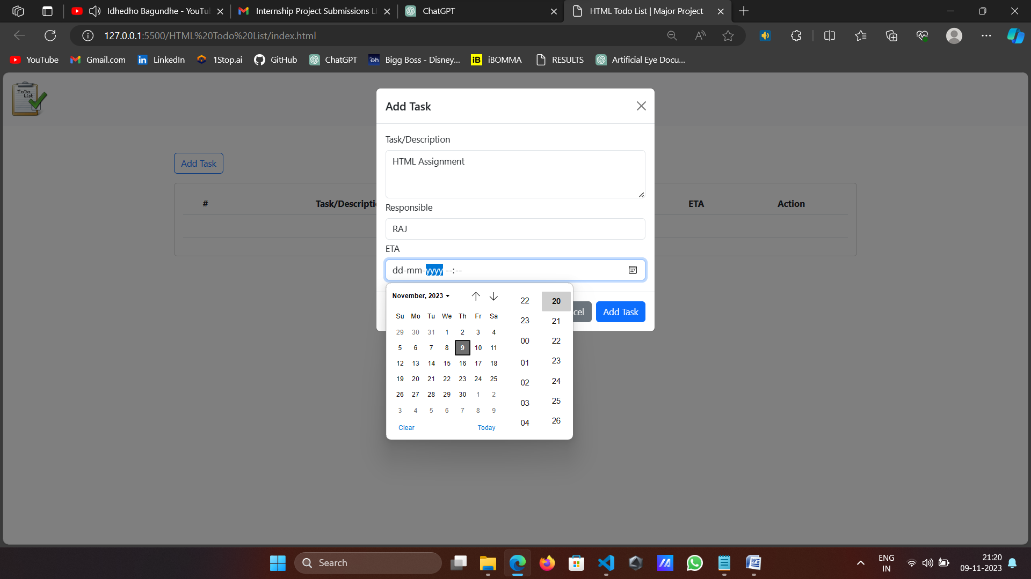

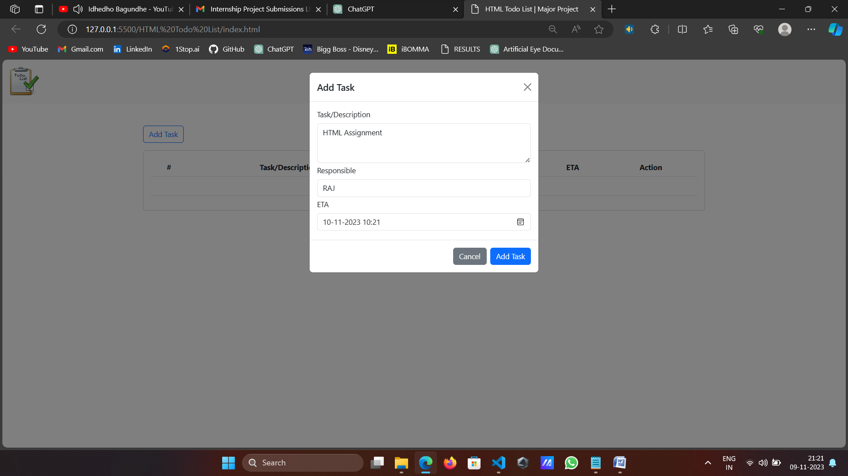
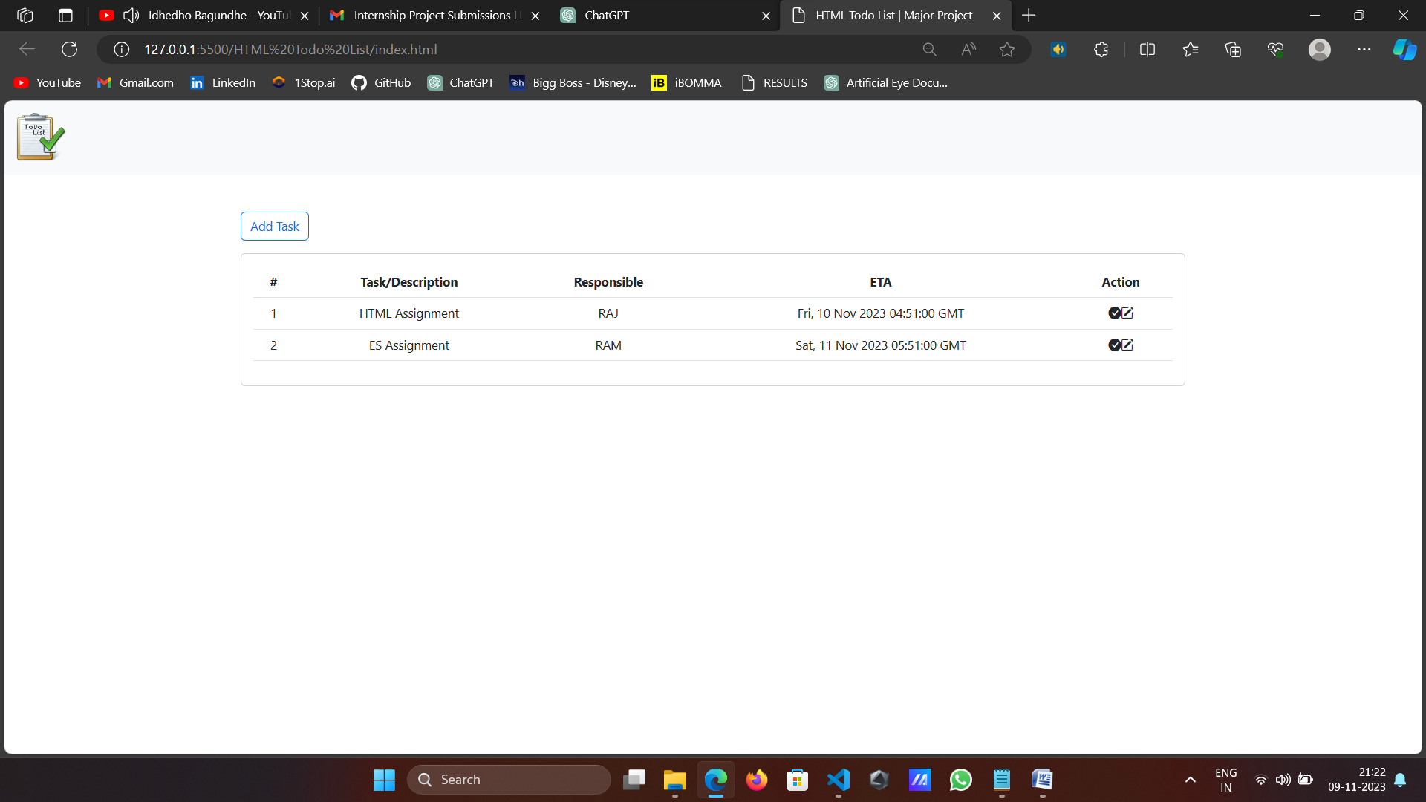

Conclusion
The HTML Todo List Major Project represents a comprehensive exploration of web development, showcasing a fully functional and user-friendly task management application. As we delve into the conclusion, we'll reflect on the key aspects of the project, its significance, and potential future directions.

- Technical Proficiency and Design Elegance: The codebase exhibits a high level of technical proficiency, leveraging essential web development technologies to create a polished and responsive user interface. The integration of Bootstrap and Bootstrap Icons streamlines the design process, ensuring a visually appealing layout that adapts seamlessly across various devices.
The navigation bar, card layout, and modals contribute to a well-organized and aesthetically pleasing user interface. The incorporation of icons adds a layer of interactivity and visual clarity, enhancing the overall user experience. The responsive design principles implemented with Bootstrap ensure that users can engage with the application effortlessly, whether on a desktop or a mobile device.

- User-Centric Functionality: At the core of this project is the task management functionality, a feature that aligns with the daily needs of users across diverse contexts. The ability to add, edit, and mark tasks as done provides a straightforward and efficient solution to the challenges of personal and professional task management.
The "Add Task" button initiates a modal, offering a guided and intuitive means of entering task details. This attention to user experience is further exemplified by the inclusion of responsible person information and an ETA (Estimated Time of Arrival), adding depth to task descriptions and enhancing the application's utility.

- Local Storage and Data Persistence: One notable feature of this project is its implementation of local storage to persistently store user-generated tasks. This approach eliminates the need for server-side databases, providing a lightweight solution for a task management application. While local storage has its limitations in terms of capacity and security, for this context, it serves the purpose of maintaining a seamless user experience.
The decision to incorporate local storage showcases a thoughtful consideration of user convenience. Users can close or refresh the page without fearing data loss, a critical aspect of any practical task management application.

- Code Modularity and Readability: The codebase demonstrates a commitment to best practices in terms of code organization and readability. Functions are modularized, handling specific tasks such as adding tasks, updating tasks, and creating HTML from storage. This modular structure not only enhances code maintainability but also sets the stage for future expansion and feature additions.
JavaScript functions communicate effectively with the Document Object Model (DOM), ensuring a dynamic and real-time update of the task list. The use of asynchronous events, such as modals and form submissions, contributes to a responsive and interactive user interface.

- Iterative Development and User Feedback: The iterative development approach employed in this project is evident through its regular testing and refinement cycles. The incorporation of user feedback is a commendable aspect, emphasizing the importance of real-world usage and user perspectives. This iterative refinement is crucial for identifying and addressing potential issues, optimizing performance, and ensuring a robust final product.

- Potential for Future Enhancements: Looking forward, the HTML Todo List project holds substantial potential for future enhancements and expansions. Its modular code structure allows for the seamless integration of additional features. Possible future developments could include task categorization, due date reminders, user authentication for personalized task lists, and collaborative features for team-based task management.
The project's extensibility and adaptability to evolving requirements position it as a foundation for continued innovation. As the landscape of web development evolves, this project provides a solid framework for integrating emerging technologies and addressing new challenges in the realm of task management.
- Educational Significance and Learning Opportunities: From an educational standpoint, this project serves as a valuable resource for aspiring web developers and enthusiasts. The codebase serves as a real-world example, illustrating the practical implementation of HTML, CSS, and JavaScript in creating a functional web application. The integration of third-party libraries and the use of design frameworks like Bootstrap offer insights into industry-standard practices.
Developers can learn from the project's approach to data persistence, user interface design, and event handling. The clean and well-commented code provides a stepping stone for those seeking to understand best practices in coding and project structuring.
- A Testament to Web Development Mastery: In conclusion, the HTML Todo List Major Project stands as a testament to the mastery of web development skills. The combination of technical proficiency, user-centric design, and code modularity results in a functional and elegant solution to a common challenge—task management.
This project not only addresses a practical need but also serves as an inspiration for developers to explore the vast possibilities within the web development landscape. As we navigate the digital era, where effective task management is integral to personal and professional success, the HTML Todo List application provides a glimpse into the potential of web technologies to simplify and enhance our daily lives.
The journey through this project is a journey through the intricacies of client-side web development, from crafting responsive layouts to handling user interactions. It emphasizes the importance of a user-centric approach, iterative development, and the continuous pursuit of improvement.
As developers engage with this project, whether for educational purposes or practical applications, it is our hope that it sparks curiosity, encourages exploration, and inspires the next wave of innovations in web development. The HTML Todo List Major Project, with its blend of functionality, design, and adaptability, serves not only as a capstone to this exploration but as a foundation for the ongoing evolution of web-based solutions to the challenges of our digital age.

